Kyoungjin Yoon

IT 106 003

Assignment 2 Pseudocode

Defining Diagram

|  |  |  |
| --- | --- | --- |
| Input | Processing | Output |
| Student_deposit  Menu  Student_meal | Prompt user for menu  Read menu  Validate menu  Prompt user for student_meal  Read student_meal  Validate student_meal  Prompt user for student_deposit  Read student_deposit  Validate student_deposit  Calculate student_deposit  Calculate meal_count  Display student_deposit, student_deposit_original, menu, meal_count | Error_invalid_menu  Error_invalid_meal  Error_insufficient_money  Error_invalid_deposit  Error_invalid_input  Student_money  Student_money_original  meal_count |

Solution Diagram

CALCULATE_STUDENT_ACCOUNT

1. set student_money to 106.00, student_deposit to zero, student_money_original to 106.00
2. set student_meal to blank, meal_count to zero
3. set error_insufficient_fund to blank, error_invalid_meal to blank, error_invaild_menu to blank, error_invalid_deposit to blank, error_invalid_input to blank

REPEAT

1. DOWHILE student_money > 4.92
2. Prompt user for meal
3. Read meal
4. IF menu NOT number THEN

Display error_invalid_menu ‘You are not allowed to enter letters, only number between 1 and 3 please.’

ENDIF

8 IF menu >=4 or menu <=0 THEN

Display error_invalid_input ‘error, only 1, 2, and 3 are allowed.’

ELSE

IF menu = 1 THEN

Prompt user for student_meal

Read student_meal

IF student_meal NOT ‘breakfast’ OR ‘lunch’ OR ‘dinner’ THEN

Display error_invalid_meal ‘You are only allowed to type either breakfast, lunch, and dinner.’

ENDIF

IF student_meal = ‘breakfast’ THEN

Student_money = student_money – 4.92

Add 1 to meal_count

ELSE

IF student_meal = ‘lunch’ THEN

Student_money = student_money – 7.06

Add 1 to meal_count

ELSE

IF student_meal = ‘dinner’ THEN

Student_money = student_money = 10.60

Add 1 to meal_count

ENDIF

ENDIF

ENDIF

ENDIF

9 IF menu = 2 THEN

Prompt user for student_deposit

Read student_deposit

IF student_deposit <= 0

Display error_invalid_deposit ‘You cannot withdraw money.’

Prompt user for student_deposit

Read student_deposit

ENDIF

Student_money = student_money + student_deposit

ENDIF

ENDDO

10 Display error_insufficient_money ‘You have insufficient money, you will be exited.’

11 UNTIL menu = 3

12 READ student_money, meal_count, student_money_original

13 Print student_money,meal_count, student_money_original

END

Input Test Data

|  |  |  |  |
| --- | --- | --- | --- |
|  | First data set | | Second data set |
| Menu | 4,2,1,1,1,1,1,1,1,1,3 | | 2,2,1,1,ONE,1, 1,1,1,1,1,1,1,1,  1,1,1,1,1,1,1,1 |
| Student_meal | lunch, lunch, breakfast, meal, breakfast, lunch, dinner, breakfast, lunch, | | breakfast, breakfast, breakfast, breakfast, breakfast, breakfast, lunch, dinner, dinner, dinner, dinner, dinner, dinner, dinner, dinner, dinner, dinner, breakfast, breakfast |
| Student_deposit | | -30.00, 0 | 20.00, 30.00 |

Expected Result

|  |  |  |  |  |
| --- | --- | --- | --- | --- |
|  | First data set | | Second data set | |
| Error_invalid_menu |  | | Error message | |
| Error_invalid_meal | Error_message | |  | |
| Error_insufficient_money |  | | Error_message | |
| Error_invalid_deposit | Error_message | |  | |
| Error_invalid_input | Error_message | |  | |
| Student_money | | 52.40 | | 3.58 |
| Student_money_original | | 106.00 | | 106.00 |
| Meal_count | | 8 | | 19 |

Desk Checking Table

It is too big to show the tables. I had to make a screenshot of the table.

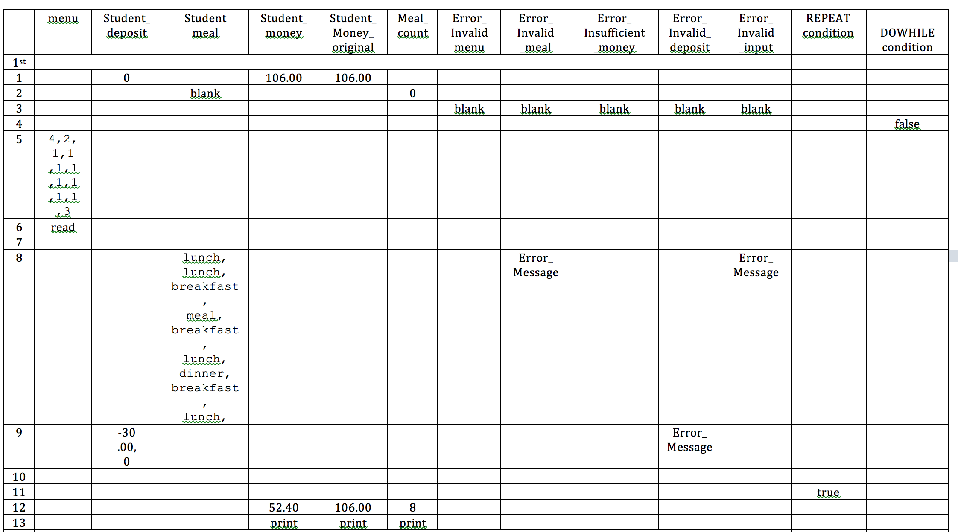

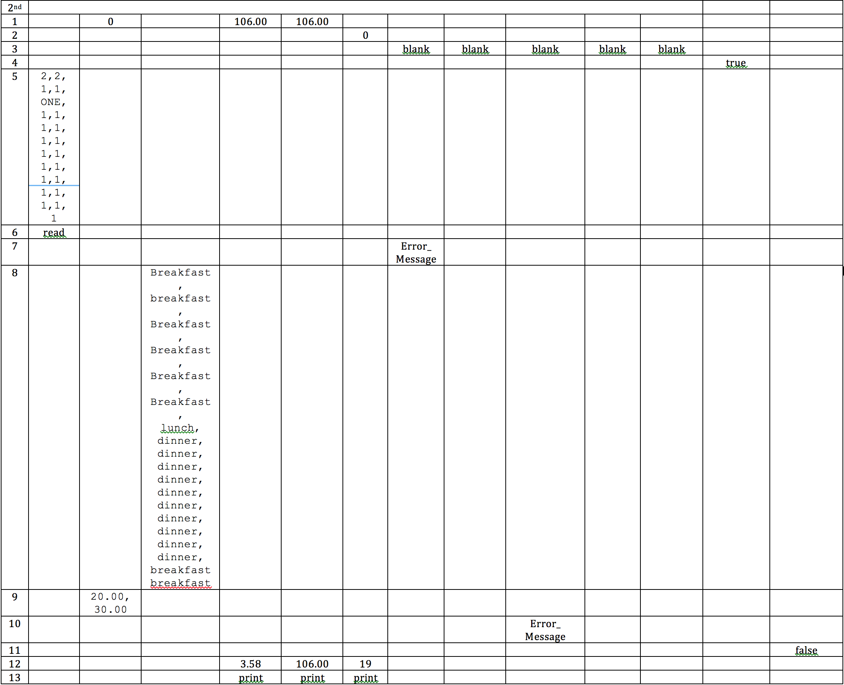

|  |  |  |  |  |  |  |  |  |  |  |  |  |  |
| --- | --- | --- | --- | --- | --- | --- | --- | --- | --- | --- | --- | --- | --- |
|  | menu | Student_  deposit | Student  meal | Student_  money | Student_  Money_  original | Meal_  count | Error_  Invalid  menu | Error_  Invalid  _meal | Error_  Insufficient  _money | Error_  Invalid_  deposit | Error_  Invalid  _input | REPEAT  condition | DOWHILE condition |
| 1st |  | | | | | | | | | | |  |  |
| 1 |  | 0 |  | 106.00 | 106.00 |  |  |  |  |  |  |  |  |
| 2 |  |  | blank |  |  | 0 |  |  |  |  |  |  |  |
| 3 |  |  |  |  |  |  | blank | blank | blank | blank | blank |  |  |
| 4 |  |  |  |  |  |  |  |  |  |  |  |  | false |
| 5 | 4,2,  1,1  ,1,1  ,1,1  ,1,1  ,3 |  |  |  |  |  |  |  |  |  |  |  |  |
| 6 | read |  |  |  |  |  |  |  |  |  |  |  |  |
| 7 |  |  |  |  |  |  |  |  |  |  |  |  |  |
| 8 |  |  | lunch,  lunch, breakfast,  meal, breakfast,  lunch, dinner, breakfast,  lunch, |  |  |  |  | Error_  Message |  |  | Error_  Message |  |  |
| 9 |  | -30  .00,  0 |  |  |  |  |  |  |  | Error_  Message |  |  |  |
| 10 |  |  |  |  |  |  |  |  |  |  |  |  |  |
| 11 |  |  |  |  |  |  |  |  |  |  |  | true |  |
| 12 |  |  |  | 52.40 | 106.00 | 8 |  |  |  |  |  |  |  |
| 13 |  |  |  | print | print | print |  |  |  |  |  |  |  |
| 2nd |  | | | | | | | | | | |  |  |
| 1 |  | 0 |  | 106.00 | 106.00 |  |  |  |  |  |  |  |  |
| 2 |  |  |  |  |  | 0 |  |  |  |  |  |  |  |
| 3 |  |  |  |  |  |  | blank | blank | blank | blank | blank |  |  |
| 4 |  |  |  |  |  |  |  |  |  |  |  | true |  |
| 5 | 2,2,  1,1,  ONE,  1,1,  1,1,  1,1,  1,1,  1,1,  1,1,  1,1,  1,1,  1 |  |  |  |  |  |  |  |  |  |  |  |  |
| 6 | read |  |  |  |  |  |  |  |  |  |  |  |  |
| 7 |  |  |  |  |  |  | Error_  Message |  |  |  |  |  |  |
| 8 |  |  | Breakfast, breakfast,  Breakfast,  Breakfast,  Breakfast,  Breakfast,  lunch, dinner, dinner, dinner, dinner, dinner, dinner, dinner, dinner, dinner, dinner, breakfast breakfast |  |  |  |  |  |  |  |  |  |  |
| 9 |  | 20.00, 30.00 |  |  |  |  |  |  |  |  |  |  |  |
| 10 |  |  |  |  |  |  |  |  | Error_  Message |  |  |  |  |
| 11 |  |  |  |  |  |  |  |  |  |  |  |  | false |
| 12 |  |  |  | 3.58 | 106.00 | 19 |  |  |  |  |  |  |  |
| 13 |  |  |  | print | print | print |  |  |  |  |  |  |  |